**Git**

**Git** is a central version control system that allows developers to collaborate and make changes to shared project.

It is a central server where we can create common folder/repositories and share with others so that everyone can make changes in their local system and push to central repositories

All team members can pull the changes from central repositories to their local machine and push changes to central repositories once they have completed work.

To pull or push changes, we have following options:

1. Using Github Desktop tool (easiest option)
2. Using Git bash (command prompt) 🡪 you will need to know the git commands
3. Using Terminal in IntelliJ or any other IDE🡪 can be done using command or without command

When multiple people are working on a single project then it is better to create branches in git repository so that everyone can work on their own branch and then we can merge their branch changes into the main branch.

Example:

Project or repository name: MyFirstProject

Main branch: main (see below image to understand where is main branch)

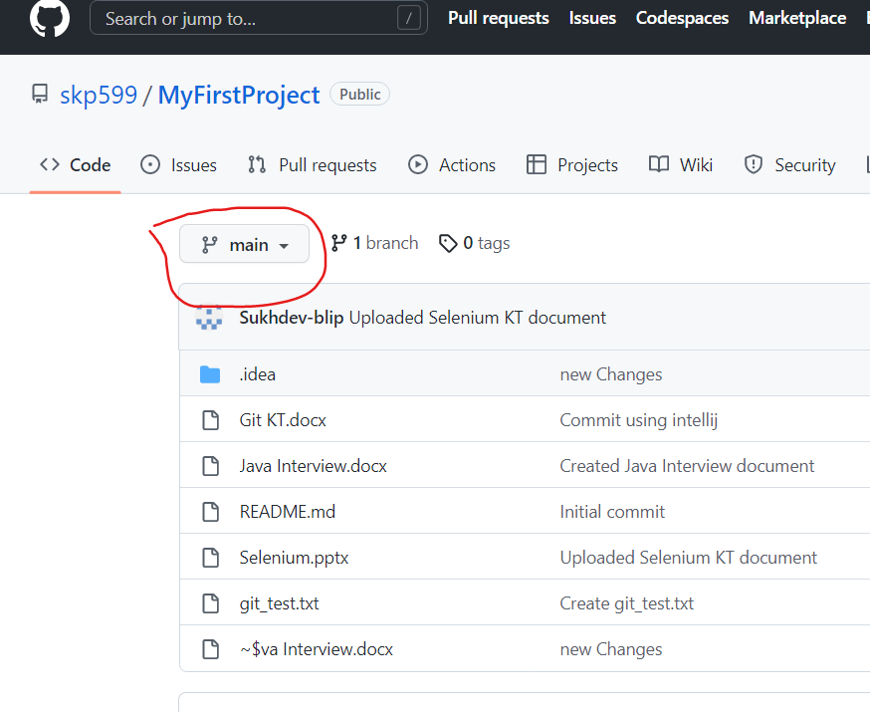

Now if Sukhdev wants to work on this project and need to add some document like Selenium KT or need to update existing documents like Java Kt etc then he can create a new local branch so that his changes will be visible only in his branch and not the main branch.

Similarly, if Shivkumar wants to work on the same project then he can create his own local branch and start working on changes in his branch.

Once Sukhdev and Shivkumar finish their work on local branches then the local branch changes can be merged into the main branch of the project.

Process to create local branches:

1. Login to git and open the project repository
2. Click on branch icon

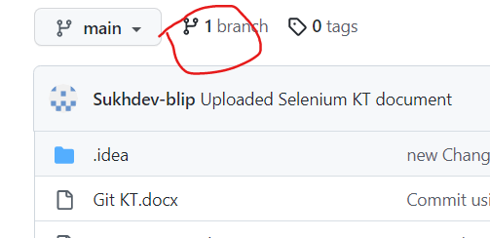

1. Then click on new branch
2. Give any branch name and select main from the source branch as you will be creating local branch from main branch only. Then click on create branch button.

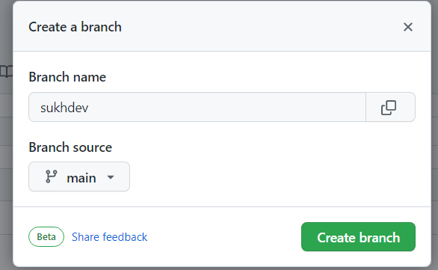

1. Once the branch is created then click on Project name or go back to main repository.
2. Select local branch Sukhdev from dropdown, see below

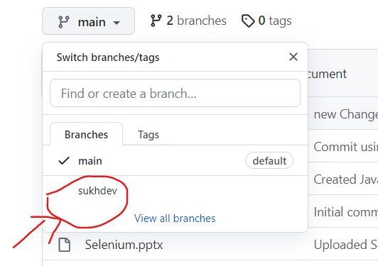

1. Or you can go to Github Desktop and choose local branch from there, see below

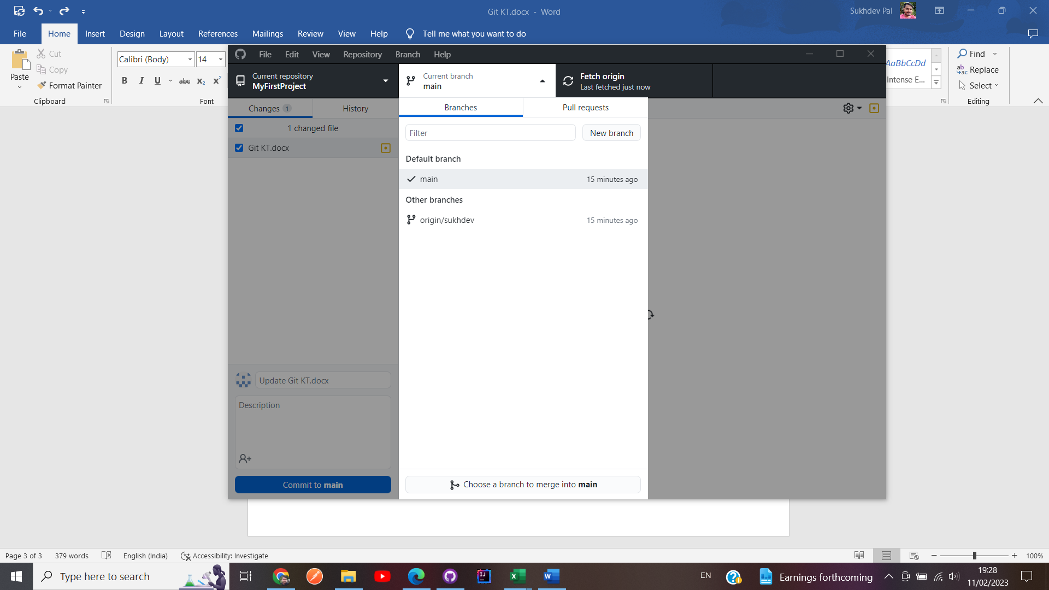

1. And then you can make any changes to files or code and push code to git using Github Desktop

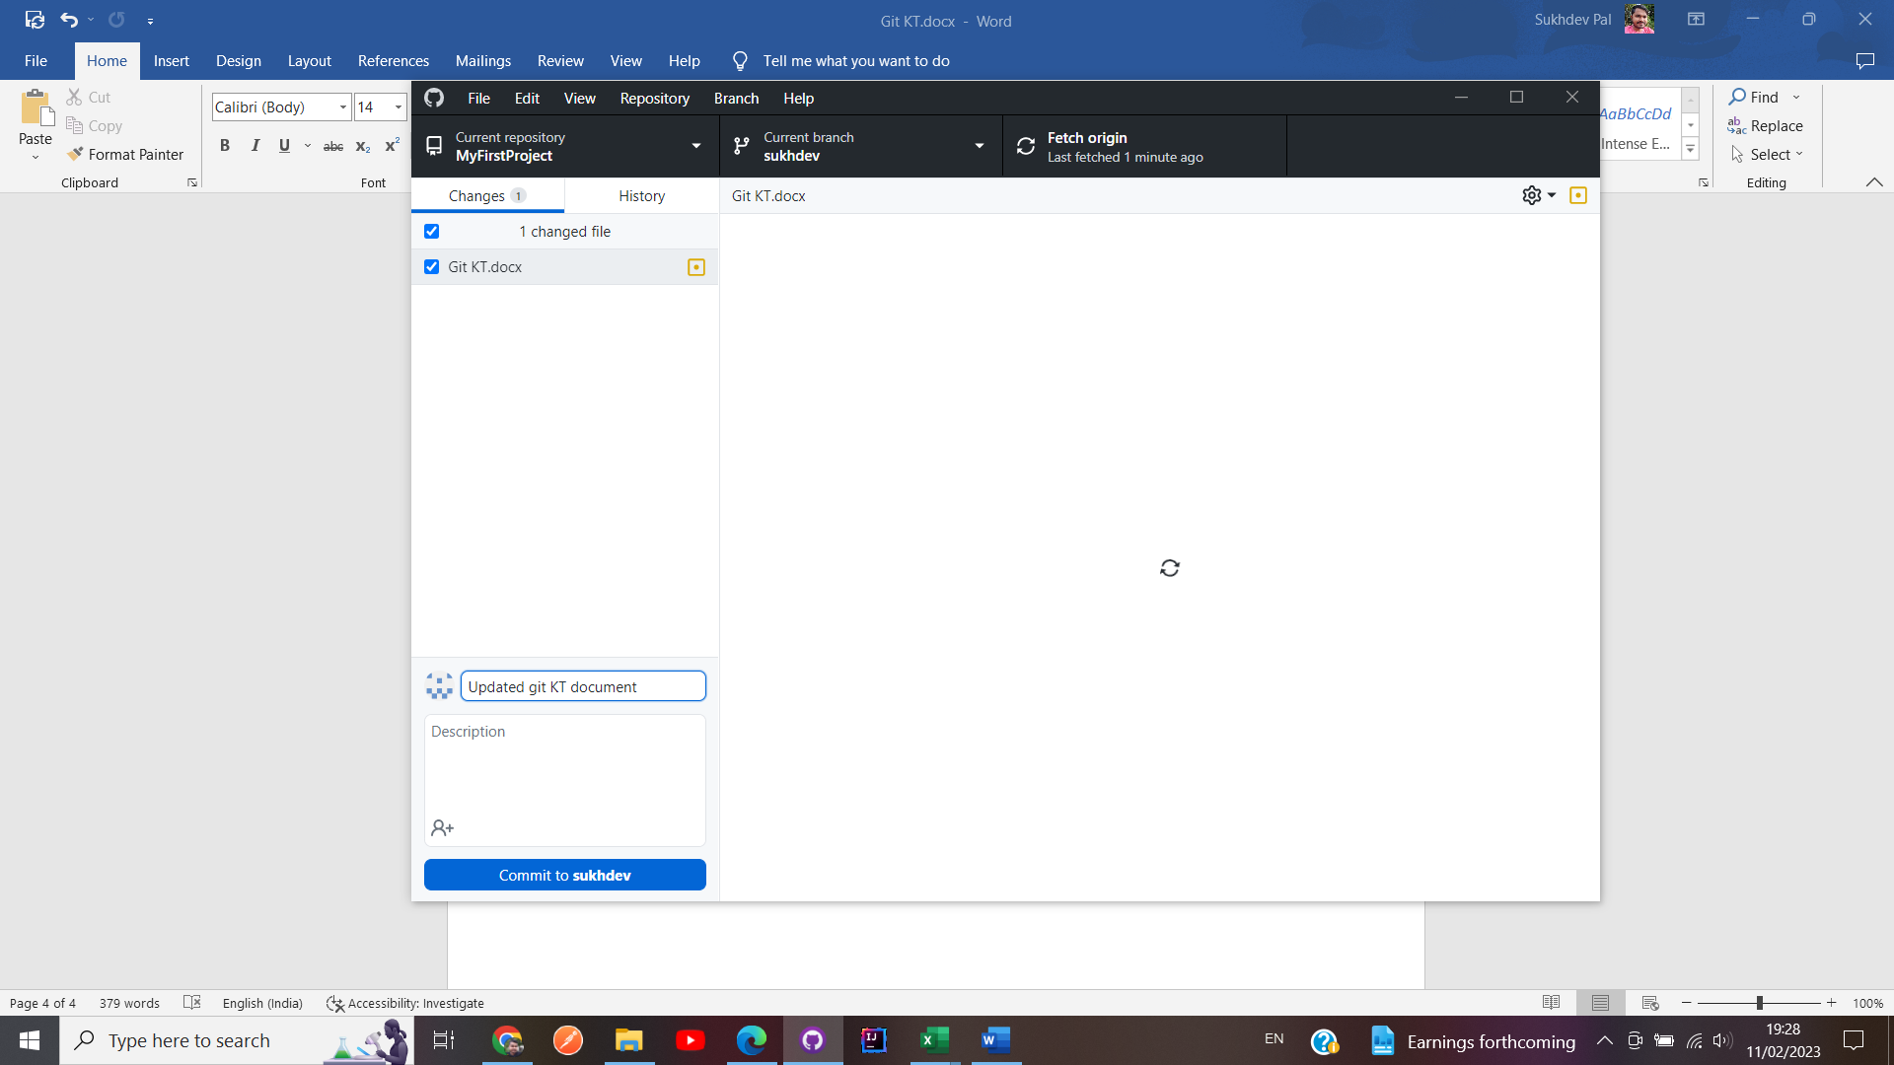

1. Once you push the changes, you will only be able to see changes in Sukhdev branch in git and not in main branch, see below

You can see changes in file only on Sukhdev branch

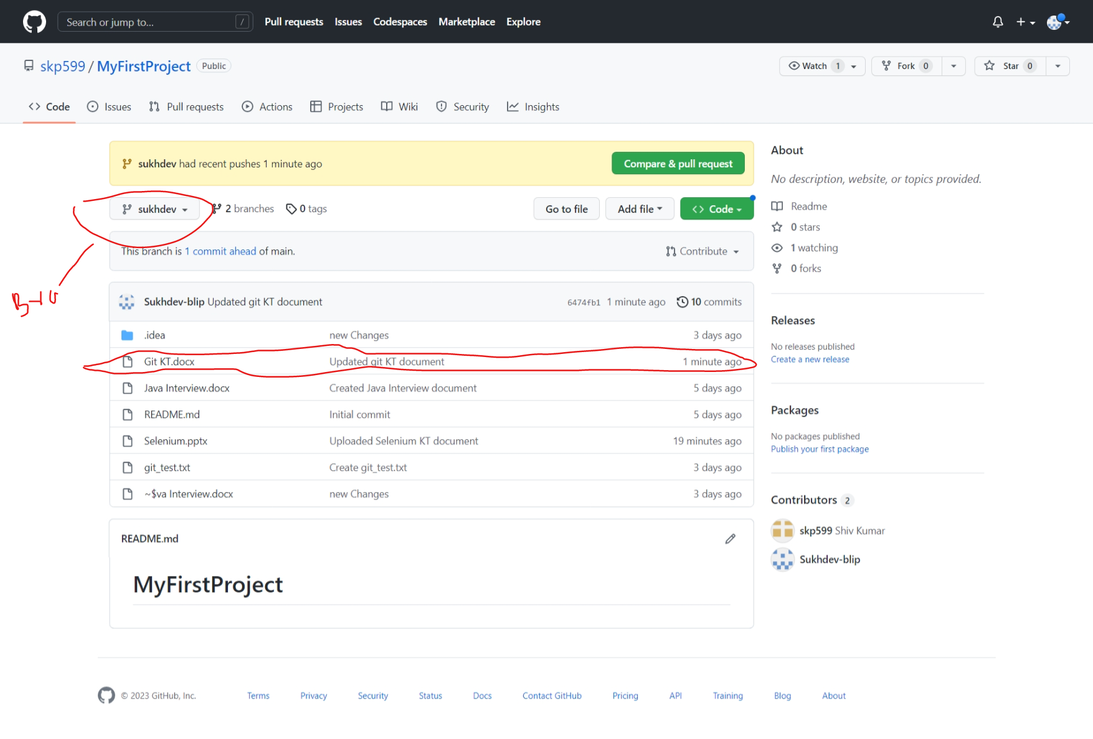

If you open main branch then you won’t see the changes, see below

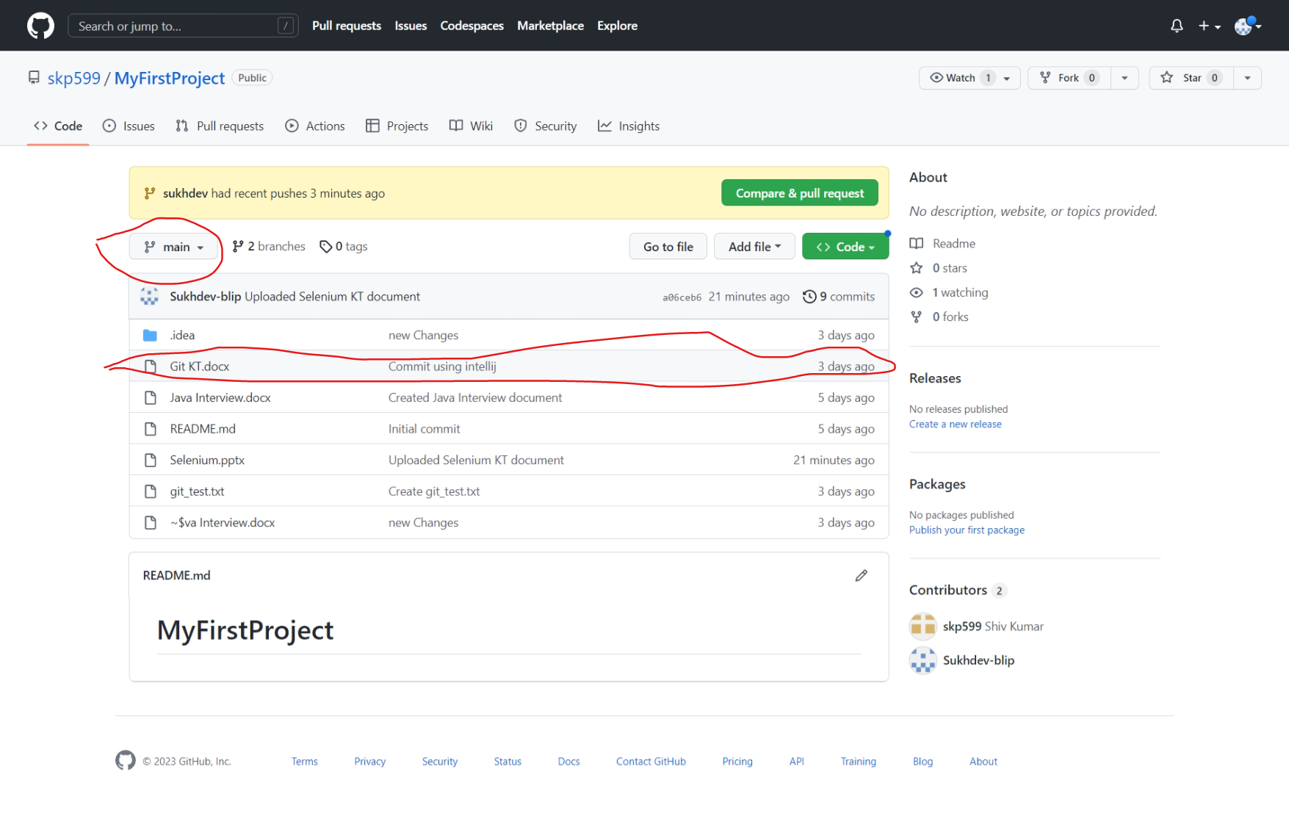

1. If you want to bring changes from Sukhdev branch to main branch then you will have to merge changes